Omission of the Odometer Correction

Project: Design an Autonomous Robot

Task: To design an autonomous robot that is capable of navigating to a predetermined position while avoiding obstacles and firing objects at two targets. This is to be done in the shortest time possible.

Document Version Number: 2.0

Hardware Version Number: 3.0

Software Version Number: 3.0

Date: April 2nd, 2015

Author: James Fuh, Gwyneth Pang, Eric Vuong

# Contents

Contents 1

Reasoning 1

Conclusions 2

# 

# Summary

The team has decided to reject the usage of the odometer correction, since it can potentially create larger errors than without the correction as seen from the odometer tests, due to the lack of correction on the theta. A solution is to localize at the shooting area once again to reset the odometer’s accuracy.

# Reasoning

According to *Odometer Correction Test v2.0*, the odometer functions when it is run by itself, since both the X and Y coordinates have a tolerable error of approximately 1.5 cm. However, the odometer correction is only capable of correcting the X and Y coordinates values, and not the heading (theta). Once the error on the theta becomes too big, the X and Y errors will become intolerable as the robot travels through its path, without any correction on theta. Thus, any slight deviation on the heading will make the X and Y coordinates intolerable. Furthermore, slight deviations will be caused by the intersection between two 4x4 grids, so changes in the heading will be inevitable, thus the omission of the odometer correction. A suggested solution was to correct the heading of the robot on the run, but this would require 2 light sensors. However, only 4 ports are allowed for the NXT brick, and the robot requires 3 ultrasonic sensors to have complete 180 degrees coverage for its front to prevent running into obstacles. As a result, there is only one port allocated to the light sensor. Therefore, odometer correction will be taken off.

# Conclusions

Possible solutions to inevitable changes in the heading which cause significant errors on the X and Y coordinates, are to either omit the odometer correction and use multiple localizations to increase the accuracy of the odometer, or to design another odometer correction that will also correct the heading. For the beta demo, the robot will localize twice: when the robot is at the starting area and when the robot is at the shooting area. In this way, there is no need to worry about the odometer correction, because the localization will fix the X and Y coordinates as well as the heading angle automatically. The results of the beta demo were very positive, so the omission is useable for the competition. However, further tests will be performed to confirm if the odometer itself is accurate enough to travel to the shooting area within a certain error tolerance.

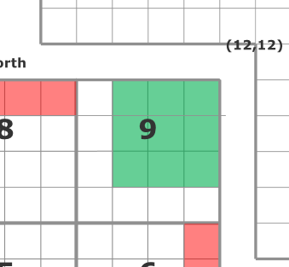

**Figure 1.** Competition shooting area

As seen from this figure, the robot only needs to get to tile (9.5, 9.5) before localization. Also, the Ultrasonic localizer part of the localization can allow an error of roughly 30cm radius from the center of the shooting area (in green) because after navigating to the shooting area, the robot can be ordered to face a wall and perform ultrasonic sensor localization. In this way, the ultrasonic sensor can be guaranteed to not read obstacles as walls and thus perform an accurate light localization after.